Practical – 3
TASK 1:
1.Execution
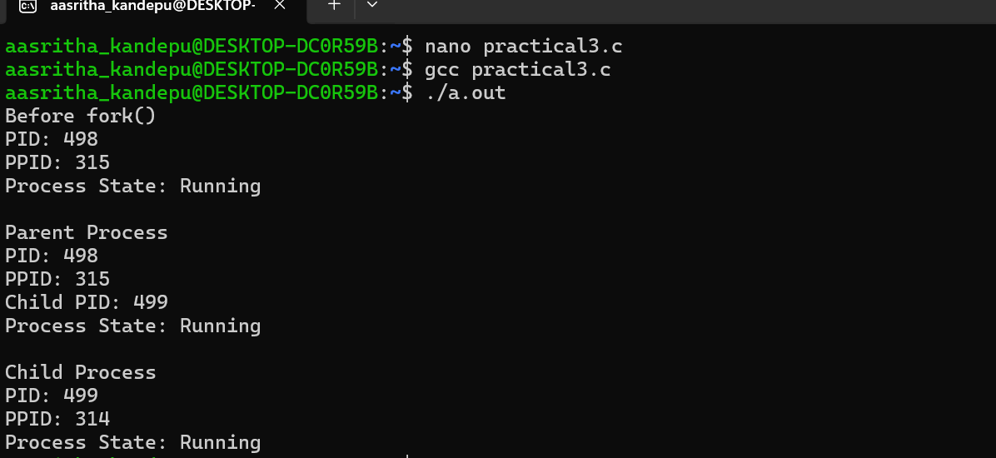
Task 2 :
Ps command:
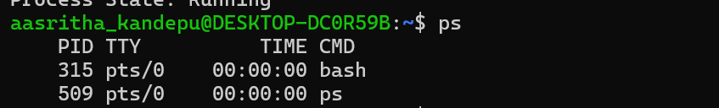
Top command:
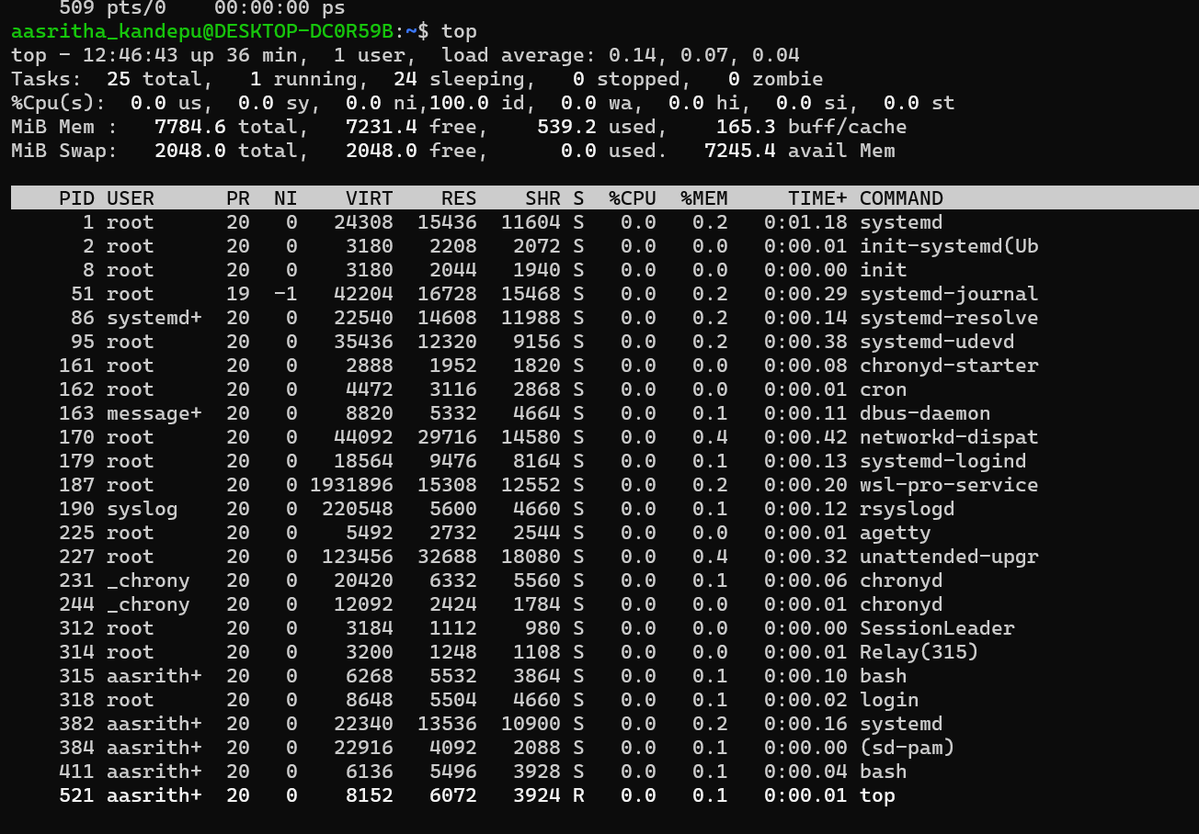
/proc command :
